

Financial Planning ● Investments ● Fiduciary ● Fee Only
560 1st Street, Suite B-203 ● Benicia, CA 94510
707.745.8756 * 707.745.8723
January 31, 2018

Dear Valued Client,
During 2017, equity markets around the world logged dramatic gains while fixed-income investments also posted very solid returns.

In sum:

- US stocks rose 21.8%.
- Foreign stocks gained 25.0%.
- Emerging market stocks posted gains of 31.5%.
- Growth strategies beat value by 10%.
- Large cap stocks beat small cap stocks by 5%.
- Investment grade bonds returned 3.5%.
- Inflation was at 2.2% in the US.

GFM client portfolio returns were generally in line with overall markets and strategies in accordance with client portfolio asset allocation specifications. Your accompanying report provides details.

In addition to impressive total gains, stock advances were remarkably unbroken by customary market turbulence - both foreign and domestic equity markets posted positive returns every calendar month of 2017 - the first such streak in history. Underpinning the market’s climb have been a strong global economic expansion, impressive corporate-earnings growth, low interest rates and investor enthusiasm for the economic initiatives of the Trump administration. That the US stock market is currently in “bubble” territory is no longer in question. The current mania about “Bitcoin”, the “cryptocurrency", is just one example of investors chasing mirages. The only remaining question is how far the bubble will expand before bursting. Today’s economic conditions suggest that the bull has further to run.

Tax Reform
The most dramatic tax reform legislation in over three decades, particularly in terms of the estimated $1.5 trillion-dollar budget deficit being generated to pay for tax cuts, was completed in December 2017. The new tax law for most households will very modestly and temporarily reduce income taxes through 2025. In addition: many tax deductions are reshuffled; state, local and mortgage deductions are subject to tighter limitations which will most directly impact taxpayers in states like California; the Obamacare individual mandate was repealed; the burden of the AMT (alternative minimum tax) is lessened; Section 529 savings plans are expanded to include K-12 schooling at public, private and religious schools; estate tax exemptions are doubled; and, taxes on business income are reduced significantly.

Essential Point: The household income tax impact of these tax law changes, which is expected to be minor on average, will depend on the details of each tax return and may be substantial.

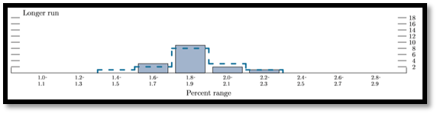
To substantiate the Trump administration’s claims that the $1.5 trillion deficit would be paid for by stimulating economic growth, the Treasury Department’s Office of Tax Policy released a one-page memo asserting without analysis that the tax reform would increase in GDP growth 0.7% on average per year over the next decade. No other analysis — from bipartisan Congressional staff, independent non-partisan tax policy groups, economists, past Republican Treasury secretaries, the IMF or the Fed — supports these claims. The IMF analysis, for example, shows that for just three years the cumulative effects of the changes will make the U.S. economy about 1.2% larger than it would have been without tax reform, but after that the bill’s impact becomes a liability, with economic growth weaker than previously estimated for the U.S. The Fed also concluded that the tax cut would only modestly increase economic growth for the next few years: “My colleagues and I are in line with the general expectation among most economists,” said Janet L. Yellen, the Fed’s chairwoman. She said they expected the bill to provide “a modest lift.”
Range of Fed Governor Expectations for GDP Growth

Essential Point: Tax reform may have no expected long-term impact on economic growth and, therefore, from a macroeconomic perspective the tax reform legislation presents no expected change in long-term investment returns. In the short-term, the tax reform impact will be added stimulus to an already fully-employed economy and therefore may raise concerns about inflation.

From an investment perspective on corporate securities and their shareholders, the impact of the tax reform is favorable in that the lowering of tax rates on corporations, all other things held the same, will permanently increase the after-tax profits of corporations by an estimated average for all stocks of 8-10%, and therefore give a similar expected boost to stock prices. This expected impact, however, cannot be measured and stock prices will continue to be determined by the usual suspects – revenues, costs, interest rates, economic growth rates, inflation, bond prices, risk aversion, new tax legislation and so on.

Essential Point: Tax reform may represent an estimated permanent 8-10% increase in the value of stocks; however, markets are complex and whatever the impact, it is impossible to see or value clearly.

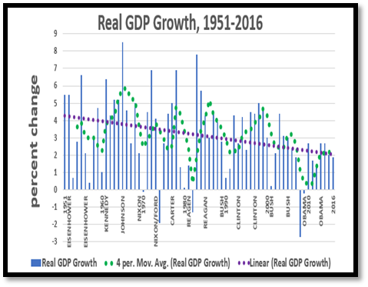
Economic Expansion
U.S. economic growth came in at about 2.3% in 2017, a relatively good showing, though far below the Trump administration’s 4% goal. On the employment front, the number of Americans filing applications for new unemployment benefits fell in January 2018 to the lowest level in nearly 45 years, another sign of economic health. The IMF also reported that the world economy now is in the “broadest synchronized global growth upsurge since 2010”. While this may be a “Goldilocks” moment, most economists continue to project that longer-term growth will remain respectable but far slower than the Administration’s forecast. The chart here of Real GDP Growth indicates that a 4% GDP growth rate would represent a surprising and major break with the past.

The View From the Fed
The Federal Reserve, heartened with a solid economy and moderate inflation, raised the Fed Funds target short-term interest rate to 1.25-1.5% in December 2017, this the fifth step up since rates were reduced to near 0% in 2009 to deal with the Great Financial Crisis. Three rate increases are expected in both 2018 and in 2019, assuming no economic surprises, to move interest rates back to a more normal setting. In sum, the Fed is looking to increase short term interest rates by about 1.5%, from the current 1.25-1.5% to 2.75-3.0%. Whether that end-point target remains fixed is subject to very serious and public debate in and out of the Fed.
Fed Expectations for Fed Funds Rate

President Trump appointed Fed Governor Jerome Powell as his next Chair of the Federal Reserve Board. A Fed governor since 2012, Powell will take over when current Chair Janet Yellen’s term expires in February. Powell is a lawyer who has held senior positions in both the corporate and government sectors. Not a formally trained economist, Powell is perceived as a centrist and not expected to change the Fed’s approach.

Rolling Back Financial Safeguards
The Trump administration is rolling-back financial safeguards put in place by Congress and the Obama administration in the aftermath of the Great Financial Crisis starting in 2007. Leadership of the Consumer Financial Protection Bureau (CFPB) now has passed to Mick Mulvaney, a vociferous critic of the CFPB who has stated his opposition to the existence of the agency. In December, Congress nullified the CFPB’s regulation prohibiting mandatory arbitration clauses in basic consumer financial agreements, wherein consumers are forced to waive their right to sue corporations. At the Department of Labor, implementation of the new fiduciary rule for financial advisors working with retirement accounts was suspended while subject to review. Meanwhile, the Securities and Exchange Commission says it is working on its own version of a fiduciary rule, though that is what the SEC has continuously said for decades without result. Moreover, the tax legislation incorporates a first-time ever tax advantage for stock-brokers, who are not fiduciaries, relative to investment advisers, who are fiduciaries; going forward, commissions paid to stock-brokers will be tax deductible while fees to investment advisors will not be tax deductible. The deregulatory roll-back applies to bank stability rules as well, and particularly to Dodd-Frank rules on the nation’s largest banks. In this context, it is noteworthy that the Vice-Chair of the Fed, Stanley Fischer, recently said: “It took almost 80 years after 1930 to have another financial crisis that could have been of [the] magnitude [of the 2007 Great Financial Crisis]. And now after 10 years everybody wants to go back to a status quo before the great financial crisis. And I find that really, extremely dangerous and extremely short-sighted…One can understand the political dynamics of this thing, but one cannot understand why grown intelligent people reach the conclusion that [you should] get rid of all the things you have put in place in the last 10 years.”

It is widely understood that the lack of financial regulation contributed the 1929 Stock Market Crash and the crash itself was a major factor leading to the Great Depression of the 1930s. The preponderance of laws regulating our current securities markets was established in the legislative response to the 1929 Stock Market Crash, including laws regulating investment advisers and stock-brokers. Over the past four decades, beginning with the Reagan Administration, deregulation has been a dominant theme in

government and that has directly affected financial markets. Many if not most economists view financial deregulation as a key factor that led to both (1) the Great Financial Crisis of the last decade, which was the worst financial crisis since the Great Depression, and (2) the Savings & Loan Crisis of the 1980s, which was at that time the worse financial crisis since the Great Depression. Both crises followed extended periods of financial deregulation and were characterized by massive fraud in major financial institutions that weak regulators were unable to properly address. The current deregulatory wave, nurtured by today’s “fake news” spirit of debate, has all the same signs of the previous eras – ideological fervor, economic self-interest, campaign donor paybacks, and political slogans about benefits for the middle class. One can only hope that it will end differently this time.

Expected Investment Returns
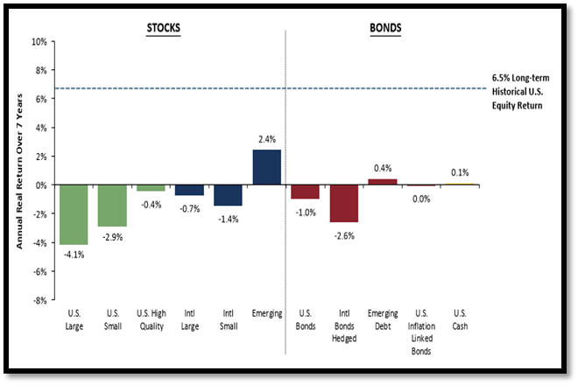
With stock markets hitting new highs, corporate profits surging, interest rates still low, tax reform, deregulation and the global economy well positioned for continued growth, what should be expected from stocks and bonds going forward? Momentum certainly suggests a continuation of a positive outlook for both stocks and bonds. But for how long? As noted in our last letter, the US stock market is so highly priced that expected long term returns are well below average. Here is an example of how one well-respected investment firm, that shares our perspective, assesses long term returns prospects; their methodology, which forecasts 7-year returns that would result if markets returned to normal trading levels, foresees negative real (inflation adjusted) returns for US and foreign stocks, as well as bonds.

Looking Ahead
Investors should curb their enthusiasm and plan realistically for relatively modest returns and much more volatility on average for years to come from both stocks and bonds. Foreign stocks are reasonably priced, but American stocks are trading at levels already far higher than 2007 and indeed only seen before the stock market crashes of 1929 and 2000; caution is therefore warranted. Bond yields are low and rising; that points to relatively low total bond returns as well.

The tax reform of 2017 will change retirement forecasts and therefore financial plans should be updated to reflect the new tax situation. While it is expected that taxes will be lower for most households, that will not be the case for everyone. Whatever the case, we believe it is now appropriate to update retirement plans.

At your convenience, please call our office to schedule a meeting. We will discuss your portfolio’s performance and, if warranted, update your investment strategy and policy statement. If you prefer, telephone and “teleweb” appointments are also available. We look forward to speaking with you soon.

Thank you for investing with us and for your continued confidence.

Sincerely,
Larry
The report is comprised of the following sections:
- Rate of Return Investment Report that indicates how your investments in aggregate have performed, absolutely and relative to your specific investment targets, and with benchmark market data that are useful comparisons.
- A summary of your portfolio allocation among asset classes.
- Position Performance Summary report that indicates how your specific investments have performed.
- A Portfolio Statement for your investments in aggregate.
- Statistical data about market indices and mutual funds that we employ.
- Statements of expenses paid on your account for trading and management.
- Also, for each of your individual accounts, a number of specific reports, including a Rate of Return Investment Report, a Capital Flows and Valuation Report (if applicable), and a Portfolio Statement.

